- Create a new process by invoking the appropriate system call. Get the process identifier of the currently running process and its respective parent using system calls and display the same using a C program.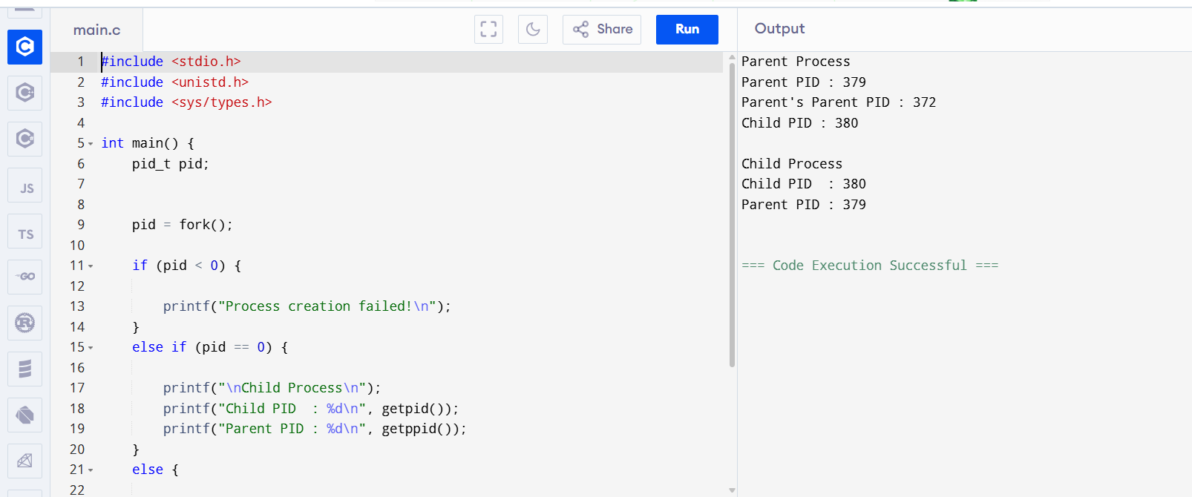 2.Identify the system calls to copy the content of one file to another and illustrate the same using a C program.
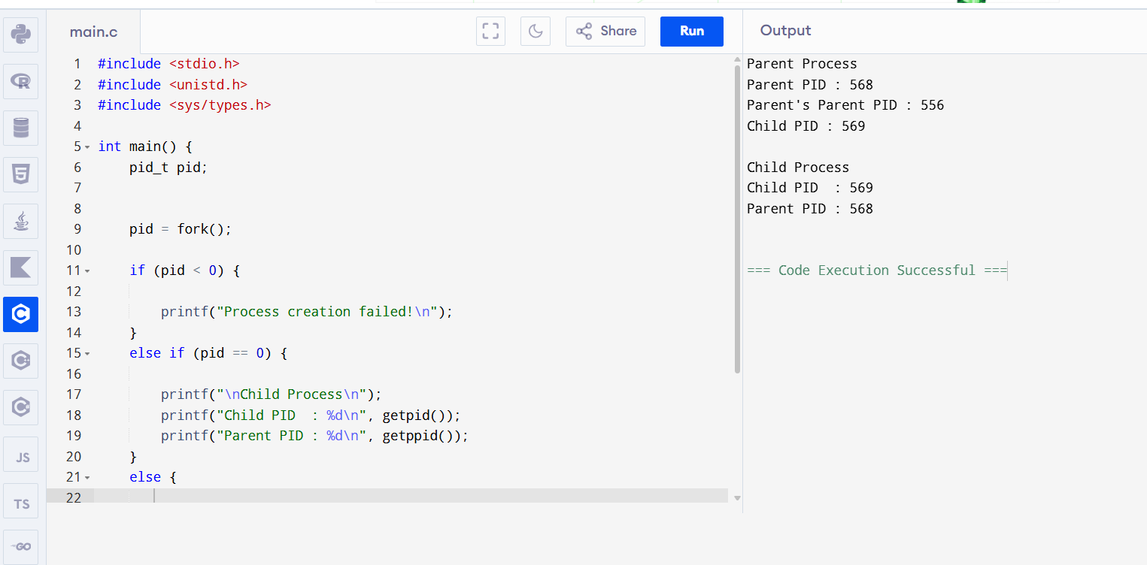 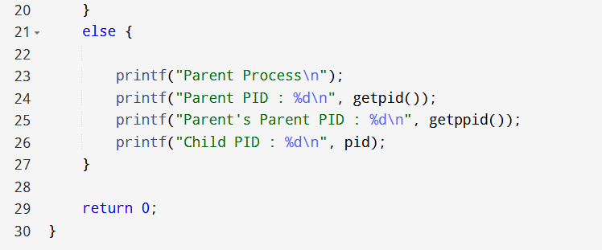3.Design a CPU scheduling program with C using First Come First Served technique with the following considerations. a. All processes are activated at time 0. b. Assume that no process waits on I/O devices 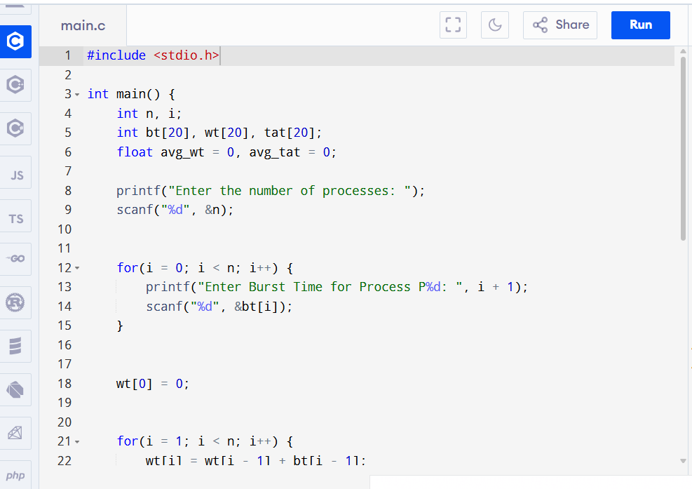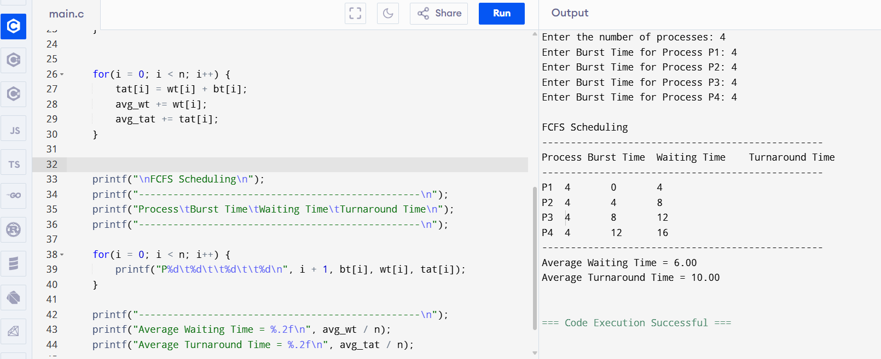

4.Construct a scheduling program with C that selects the waiting process with the smallest execution time to execute next 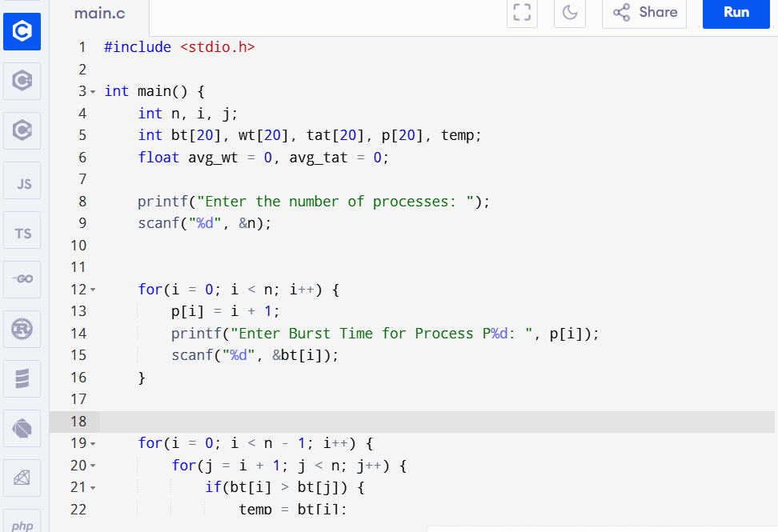

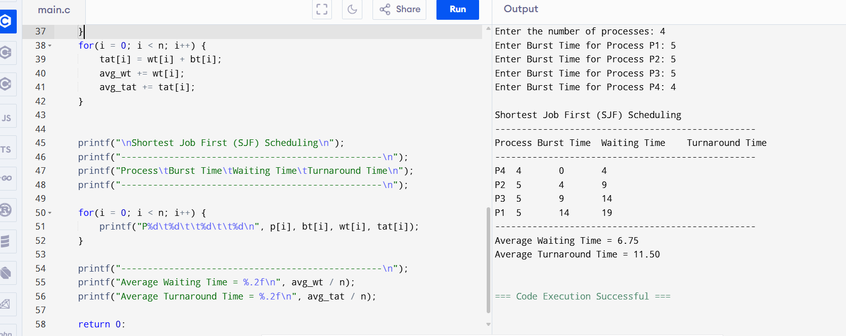

5.Construct a scheduling program with C that selects the waiting process with the highest priority to execute next.
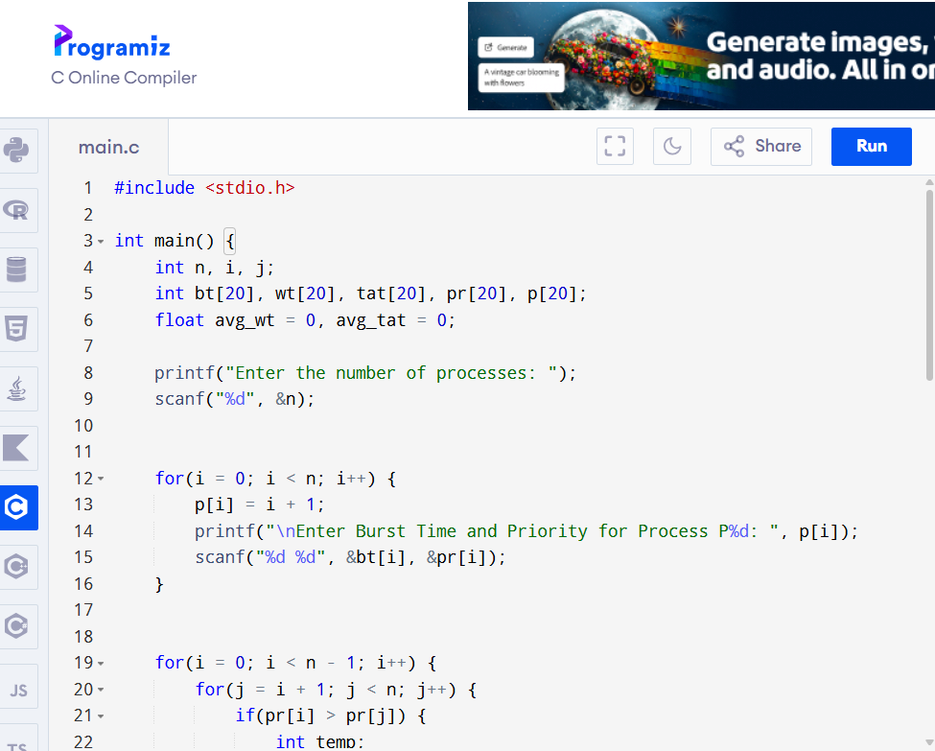

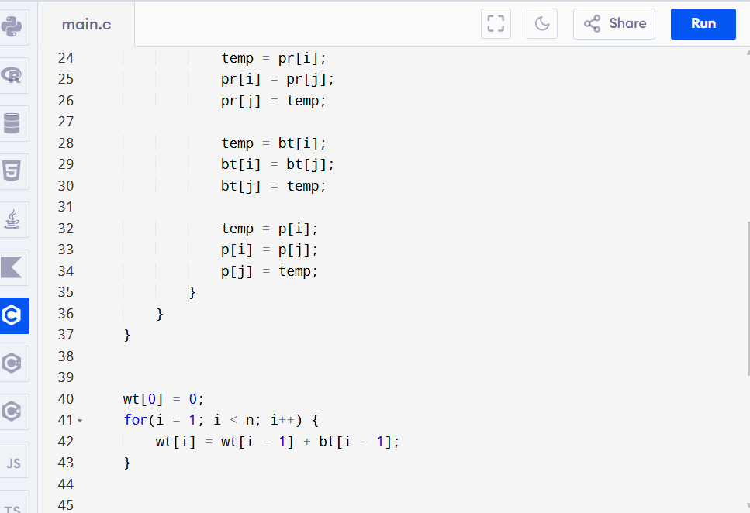
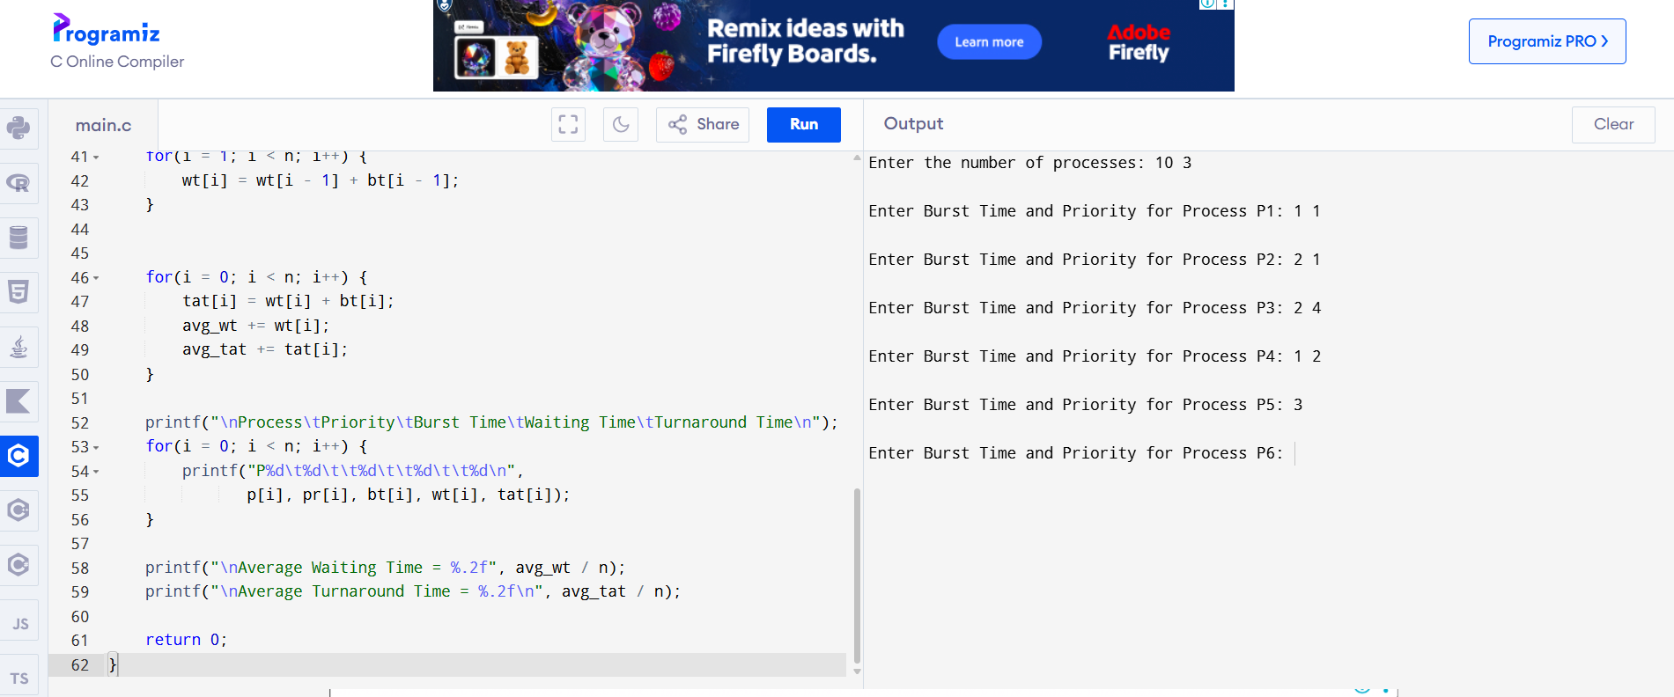

6.Construct a C program to implement preemptive priority scheduling algorithm
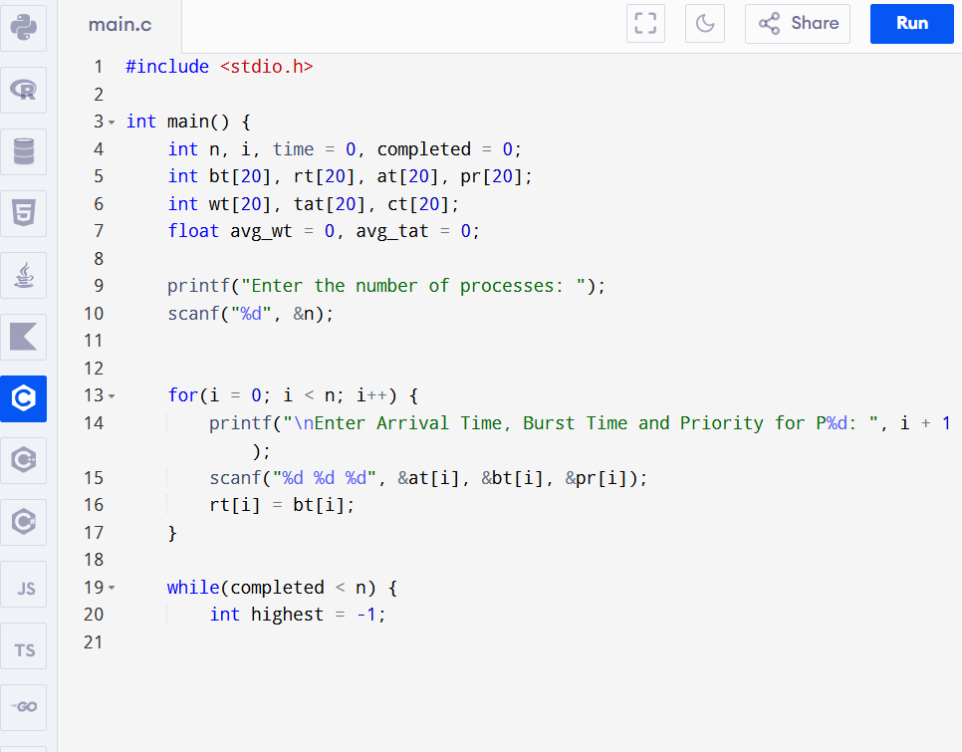
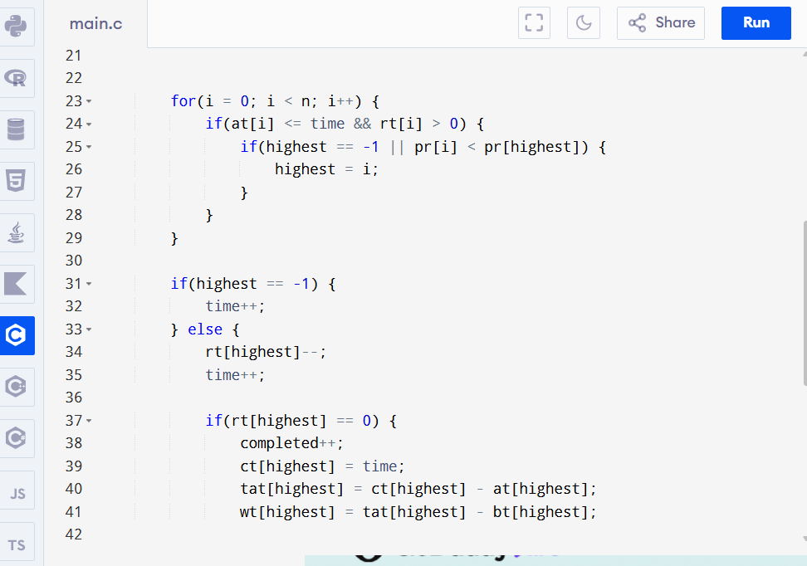

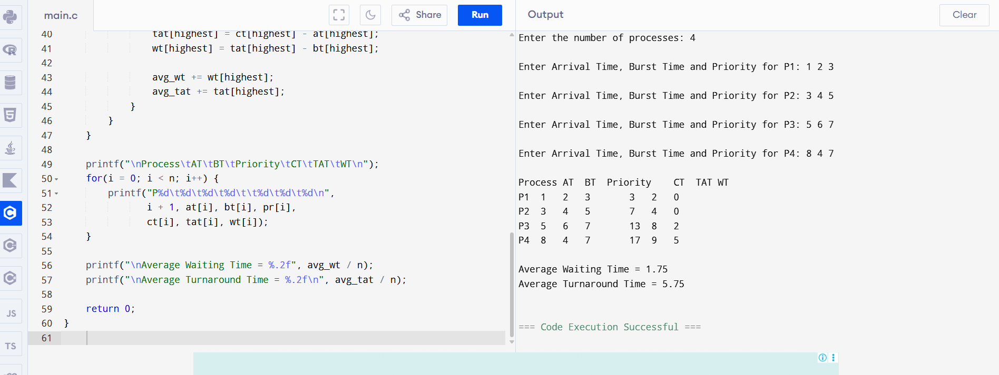

7. Construct a C program to implement a non-preemptive SJF algorithm.
#include <stdio.h>

int main() {
int n, i, j;
int bt[20], at[20], wt[20], tat[20], ct[20];
int completed[20] = {0};
int time = 0, done = 0;
float avg_wt = 0, avg_tat = 0;

printf("Enter the number of processes: ");
scanf("%d", &n);

// Input Arrival Time and Burst Time
for(i = 0; i < n; i++) {
printf("Enter Arrival Time and Burst Time for P%d: ", i + 1);
scanf("%d %d", &at[i], &bt[i]);
}

while(done < n) {
int shortest = -1;

// Find the shortest job among arrived processes
for(i = 0; i < n; i++) {
if(at[i] <= time && completed[i] == 0) {
if(shortest == -1 || bt[i] < bt[shortest]) {
shortest = i;
}
}
}

if(shortest == -1) {
time++; // CPU is idle
} else {
time += bt[shortest];
ct[shortest] = time;
tat[shortest] = ct[shortest] - at[shortest];
wt[shortest] = tat[shortest] - bt[shortest];

completed[shortest] = 1;
done++;

avg_wt += wt[shortest];
avg_tat += tat[shortest];
}
}

printf("\nProcess\tAT\tBT\tCT\tTAT\tWT\n");
for(i = 0; i < n; i++) {
printf("P%d\t%d\t%d\t%d\t%d\t%d\n",
i + 1, at[i], bt[i], ct[i], tat[i], wt[i]);
}

printf("\nAverage Waiting Time = %.2f", avg_wt / n);
printf("\nAverage Turnaround Time = %.2f\n", avg_tat / n);

return 0;
}

Output:
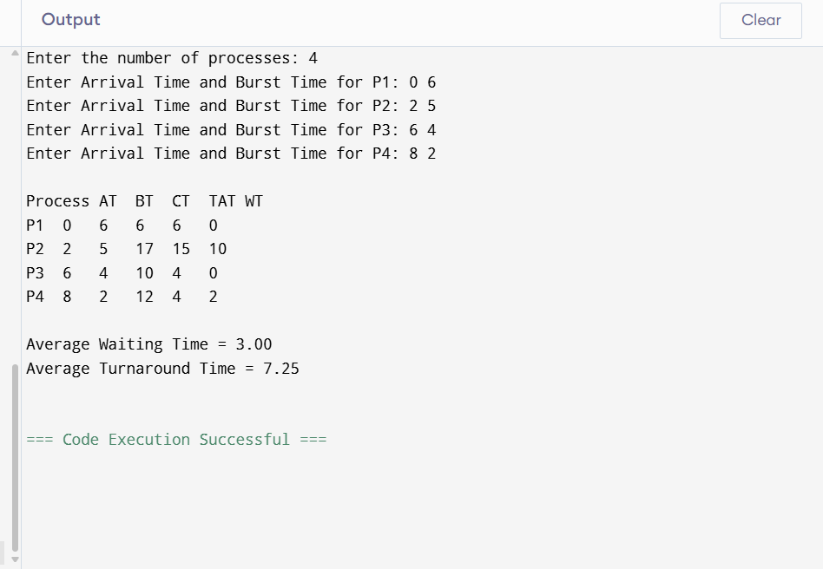

8. Construct a C program to simulate Round Robin scheduling algorithm with C.

#include <stdio.h>

int main() {
int n, i, tq;
int bt[20], rt[20], wt[20], tat[20];
int time = 0, completed = 0;

printf("Enter the number of processes: ");
scanf("%d", &n);

// Input Burst Time
for(i = 0; i < n; i++) {
printf("Enter Burst Time for P%d: ", i + 1);
scanf("%d", &bt[i]);
rt[i] = bt[i]; // Remaining Time
}

printf("Enter Time Quantum: ");
scanf("%d", &tq);

while(completed < n) {
int done = 1;

for(i = 0; i < n; i++) {
if(rt[i] > 0) {
done = 0;

if(rt[i] > tq) {
time += tq;
rt[i] -= tq;
} else {
time += rt[i];
wt[i] = time - bt[i];
rt[i] = 0;
completed++;
}
}
}

if(done)
break;
}

// Calculate Turnaround Time
float avg_wt = 0, avg_tat = 0;

for(i = 0; i < n; i++) {
tat[i] = bt[i] + wt[i];
avg_wt += wt[i];
avg_tat += tat[i];
}

printf("\nProcess\tBurst Time\tWaiting Time\tTurnaround Time\n");
for(i = 0; i < n; i++) {
printf("P%d\t%d\t\t%d\t\t%d\n",
i + 1, bt[i], wt[i], tat[i]);
}

printf("\nAverage Waiting Time = %.2f", avg_wt / n);
printf("\nAverage Turnaround Time = %.2f\n", avg_tat / n);

return 0;
}
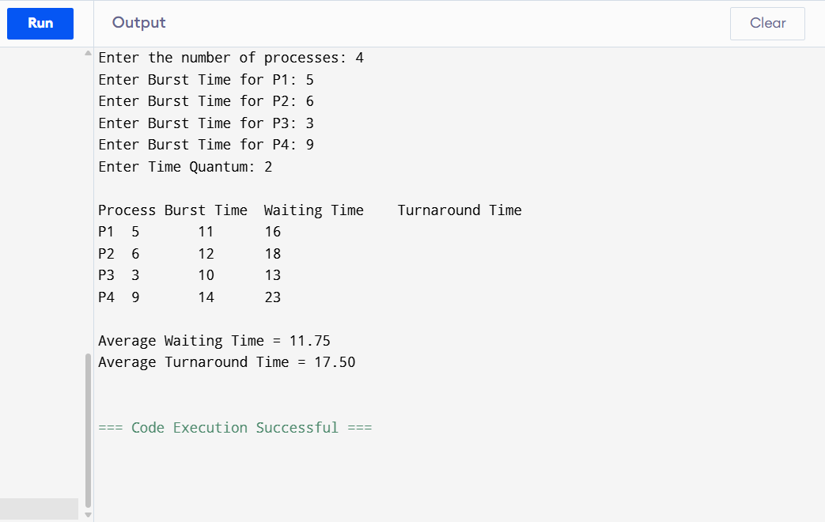
9. Illustrate the concept of inter-process communication using shared memory with a C program.

#include <stdio.h>
#include <stdlib.h>
#include <string.h>
#include <unistd.h>
#include <sys/ipc.h>
#include <sys/shm.h>
#include <sys/types.h>
#include <sys/wait.h>

int main() {
key_t key = 1234;
int shmid;
char *shm_ptr;

// Create shared memory
shmid = shmget(key, 1024, 0666 | IPC_CREAT);
if (shmid < 0) {
perror("shmget");
exit(1);
}

// Attach shared memory
shm_ptr = (char *)shmat(shmid, NULL, 0);
if (shm_ptr == (char *)-1) {
perror("shmat");
exit(1);
}

if (fork() == 0) {
// Child process
sleep(1); // Wait for parent to write
printf("Child Process Read: %s\n", shm_ptr);

// Detach shared memory
shmdt(shm_ptr);
} else {
// Parent process
strcpy(shm_ptr, "Hello from Parent using Shared Memory!");

printf("Parent Process Wrote: %s\n", shm_ptr);

wait(NULL);

// Detach and remove shared memory
shmdt(shm_ptr);
shmctl(shmid, IPC_RMID, NULL);
}

return 0;
}
Output:
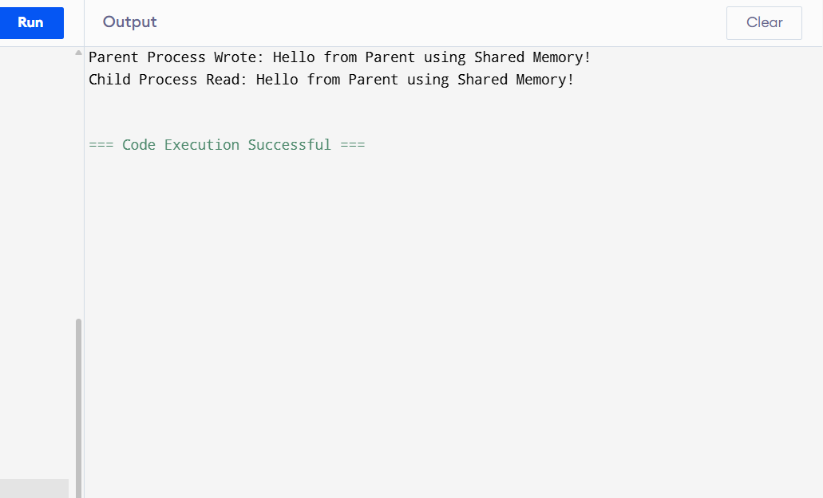

10. Illustrate the concept of inter-process communication using message queue with a C program.

#include <stdio.h>
#include <stdlib.h>
#include <string.h>
#include <unistd.h>
#include <sys/ipc.h>
#include <sys/msg.h>
#include <sys/types.h>
#include <sys/wait.h>

// Structure for the message
struct message {
long msg_type;
char msg_text[100];
};

int main() {
key_t key = 1234;
int msgid;
struct message msg;

// Create message queue
msgid = msgget(key, 0666 | IPC_CREAT);
if (msgid == -1) {
perror("msgget");
exit(1);
}

if (fork() == 0) {
// Child process: Receive message
msgrcv(msgid, &msg, sizeof(msg.msg_text), 1, 0);
printf("Child Process Received: %s\n", msg.msg_text);
} else {
// Parent process: Send message
msg.msg_type = 1;
strcpy(msg.msg_text, "Hello from Parent using Message Queue!");

msgsnd(msgid, &msg, sizeof(msg.msg_text), 0);
printf("Parent Process Sent: %s\n", msg.msg_text);

wait(NULL);

// Remove the message queue
msgctl(msgid, IPC_RMID, NULL);
}

return 0;
}

Output:
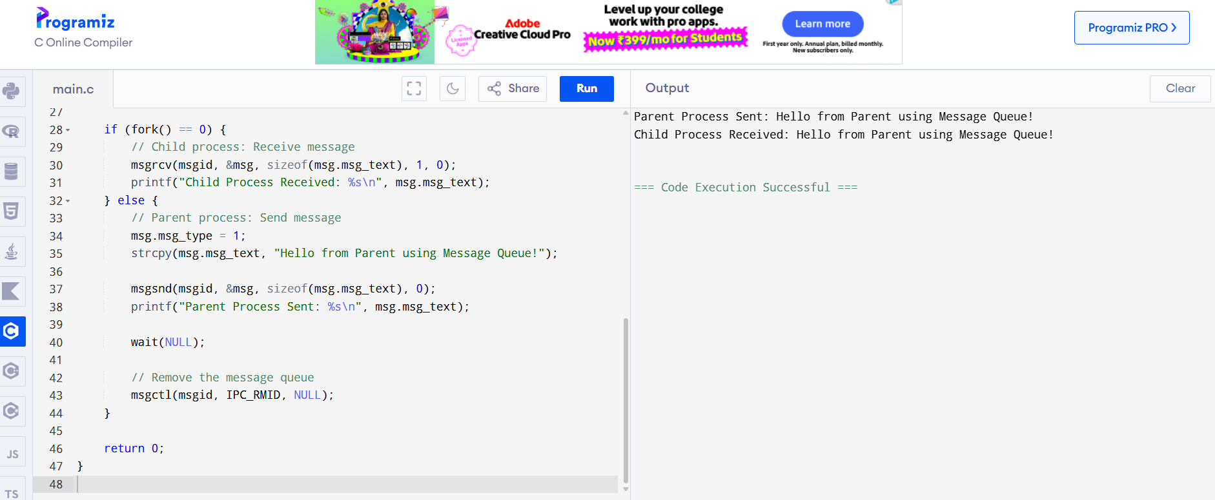

11. Illustrate the concept of multithreading using a C program.
#include <stdio.h>
#include <stdlib.h>
#include <pthread.h>

// Function executed by Thread 1
void *thread1(void *arg) {
printf("Thread 1 is running.\n");
pthread_exit(NULL);
}

// Function executed by Thread 2
void *thread2(void *arg) {
printf("Thread 2 is running.\n");
pthread_exit(NULL);
}

int main() {
pthread_t t1, t2;

// Create Thread 1
if (pthread_create(&t1, NULL, thread1, NULL) != 0) {
printf("Error creating Thread 1\n");
return 1;
}

// Create Thread 2
if (pthread_create(&t2, NULL, thread2, NULL) != 0) {
printf("Error creating Thread 2\n");
return 1;
}

// Wait for both threads to finish
pthread_join(t1, NULL);
pthread_join(t2, NULL);

printf("Both threads have finished execution.\n");

return 0;
}

Output:
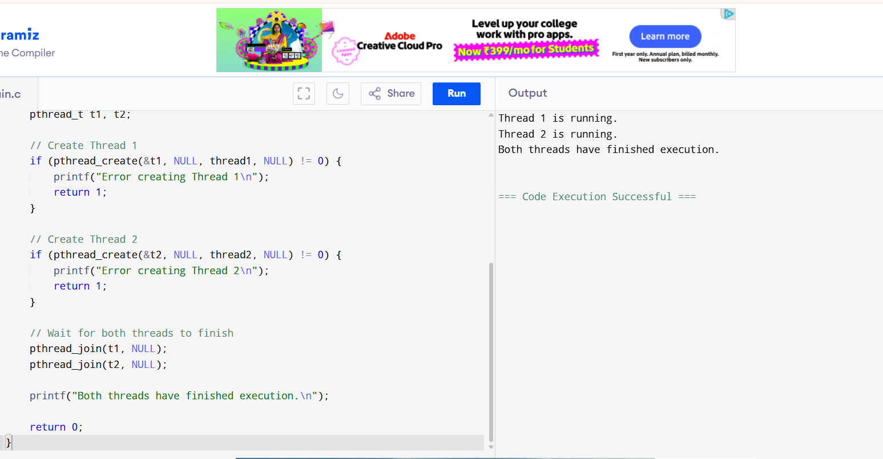

12.Design a C program to simulate the concept of Dining-Philosophers problem

#include <stdio.h>
#include <stdlib.h>
#include <pthread.h>
#include <unistd.h>

#define N 5

pthread_mutex_t fork_mutex[N];

void *philosopher(void *num) {
int id = *(int *)num;

printf("Philosopher %d is Thinking\n", id);

// Pick up left fork
pthread_mutex_lock(&fork_mutex[id]);
printf("Philosopher %d picked up Left Fork %d\n", id, id);

// Pick up right fork
pthread_mutex_lock(&fork_mutex[(id + 1) % N]);
printf("Philosopher %d picked up Right Fork %d\n", id, (id + 1) % N);

// Eat
printf("Philosopher %d is Eating\n", id);
sleep(1);

// Put down forks
pthread_mutex_unlock(&fork_mutex[id]);
pthread_mutex_unlock(&fork_mutex[(id + 1) % N]);

printf("Philosopher %d finished Eating and released forks\n", id);

pthread_exit(NULL);
}

int main() {
pthread_t tid[N];
int phil[N];

// Initialize mutexes
for (int i = 0; i < N; i++) {
pthread_mutex_init(&fork_mutex[i], NULL);
phil[i] = i;
}

// Create philosopher threads
for (int i = 0; i < N; i++) {
pthread_create(&tid[i], NULL, philosopher, &phil[i]);
}

// Wait for all philosophers
for (int i = 0; i < N; i++) {
pthread_join(tid[i], NULL);
}

// Destroy mutexes
for (int i = 0; i < N; i++) {
pthread_mutex_destroy(&fork_mutex[i]);
}

return 0;
}

Output:

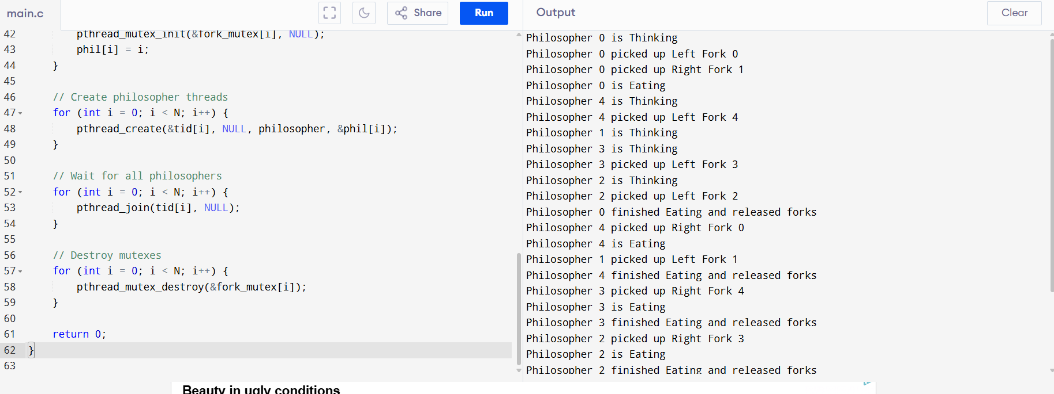

13. Construct a C program for implementation of the various memory allocation strategies.

#include <stdio.h>
void firstFit(int blockSize[], int m, int processSize[], int n) {
int allocation[n];
for(int i = 0; i < n; i++)
allocation[i] = -1;

for(int i = 0; i < n; i++) {
for(int j = 0; j < m; j++) {
if(blockSize[j] >= processSize[i]) {
allocation[i] = j;
blockSize[j] -= processSize[i];
break;
}
}
}

printf("\nFirst Fit Allocation\n");
printf("Process\tSize\tBlock\n");
for(int i = 0; i < n; i++) {
if(allocation[i] != -1)
printf("%d\t%d\t%d\n", i + 1, processSize[i], allocation[i] + 1);
else
printf("%d\t%d\tNot Allocated\n", i + 1, processSize[i]);
}
}

void bestFit(int blockSize[], int m, int processSize[], int n) {
int allocation[n];
for(int i = 0; i < n; i++)
allocation[i] = -1;

for(int i = 0; i < n; i++) {
int best = -1;
for(int j = 0; j < m; j++) {
if(blockSize[j] >= processSize[i]) {
if(best == -1 || blockSize[j] < blockSize[best])
best = j;
}
}

if(best != -1) {
allocation[i] = best;
blockSize[best] -= processSize[i];
}
}

printf("\nBest Fit Allocation\n");
printf("Process\tSize\tBlock\n");
for(int i = 0; i < n; i++) {
if(allocation[i] != -1)
printf("%d\t%d\t%d\n", i + 1, processSize[i], allocation[i] + 1);
else
printf("%d\t%d\tNot Allocated\n", i + 1, processSize[i]);
}
}

void worstFit(int blockSize[], int m, int processSize[], int n) {
int allocation[n];
for(int i = 0; i < n; i++)
allocation[i] = -1;

for(int i = 0; i < n; i++) {
int worst = -1;
for(int j = 0; j < m; j++) {
if(blockSize[j] >= processSize[i]) {
if(worst == -1 || blockSize[j] > blockSize[worst])
worst = j;
}
}

if(worst != -1) {
allocation[i] = worst;
blockSize[worst] -= processSize[i];
}
}

printf("\nWorst Fit Allocation\n");
printf("Process\tSize\tBlock\n");
for(int i = 0; i < n; i++) {
if(allocation[i] != -1)
printf("%d\t%d\t%d\n", i + 1, processSize[i], allocation[i] + 1);
else
printf("%d\t%d\tNot Allocated\n", i + 1, processSize[i]);
}
}

int main() {
int m, n;

printf("Enter number of memory blocks: ");
scanf("%d", &m);

int block[m], block1[m], block2[m];

printf("Enter block sizes:\n");
for(int i = 0; i < m; i++) {
scanf("%d", &block[i]);
block1[i] = block[i];
block2[i] = block[i];
}

printf("Enter number of processes: ");
scanf("%d", &n);

int process[n];

printf("Enter process sizes:\n");
for(int i = 0; i < n; i++)
scanf("%d", &process[i]);

firstFit(block, m, process, n);
bestFit(block1, m, process, n);
worstFit(block2, m, process, n);

return 0;
}

Output:

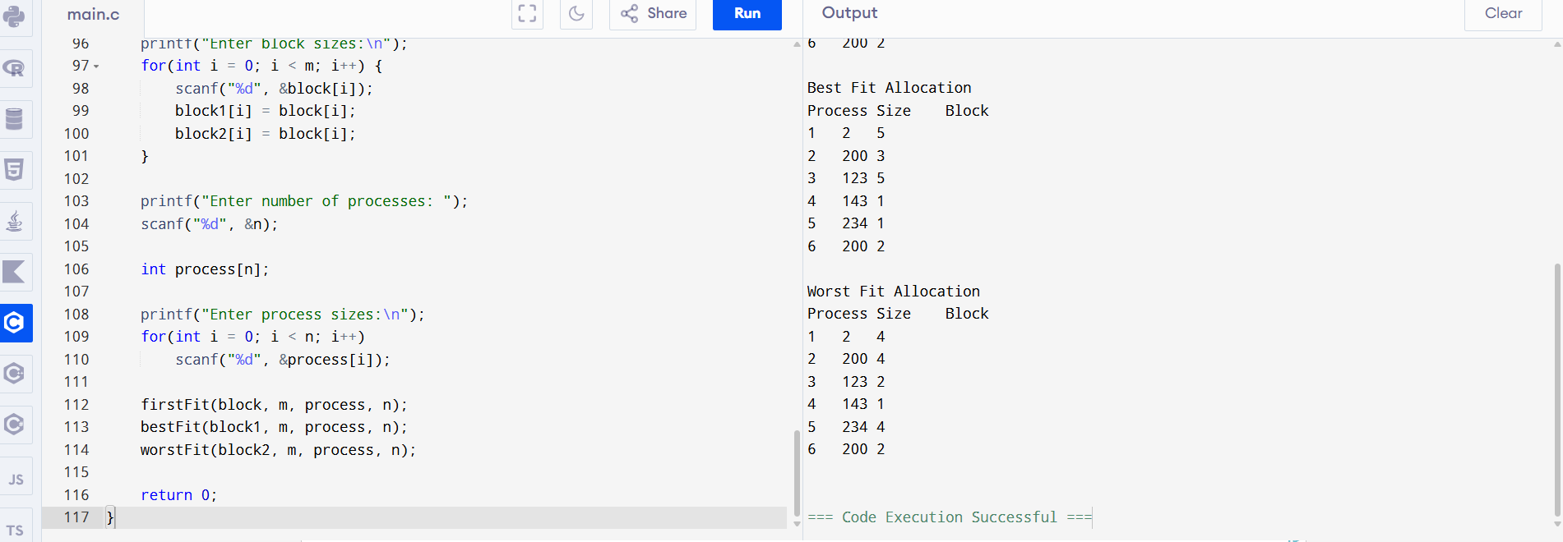

14. Construct a C program to organise the file using a single level directory.

#include <stdio.h>
#include <string.h>
#include <stdlib.h>

#define MAX 50

struct file {
char name[20];
};

struct file directory[MAX];
int count = 0;

// Function to create a file
void createFile() {
char filename[20];

printf("Enter file name: ");
scanf("%s", filename);

for(int i = 0; i < count; i++) {
if(strcmp(directory[i].name, filename) == 0) {
printf("File already exists!\n");
return;
}
}

strcpy(directory[count].name, filename);
count++;

printf("File created successfully.\n");
}

// Function to search a file
void searchFile() {
char filename[20];

printf("Enter file name to search: ");
scanf("%s", filename);

for(int i = 0; i < count; i++) {
if(strcmp(directory[i].name, filename) == 0) {
printf("File found.\n");
return;
}
}

printf("File not found.\n");
}

// Function to delete a file
void deleteFile() {
char filename[20];

printf("Enter file name to delete: ");
scanf("%s", filename);

for(int i = 0; i < count; i++) {
if(strcmp(directory[i].name, filename) == 0) {
for(int j = i; j < count - 1; j++) {
strcpy(directory[j].name, directory[j + 1].name);
}

count--;
printf("File deleted successfully.\n");
return;
}
}

printf("File not found.\n");
}

// Function to display files
void displayFiles() {
if(count == 0) {
printf("Directory is empty.\n");
return;
}

printf("\nFiles in Directory:\n");
for(int i = 0; i < count; i++) {
printf("%s\n", directory[i].name);
}
}

int main() {
int choice;

while(1) {
printf("\n--- Single Level Directory ---\n");
printf("1. Create File\n");
printf("2. Search File\n");
printf("3. Delete File\n");
printf("4. Display Files\n");
printf("5. Exit\n");

printf("Enter your choice: ");
scanf("%d", &choice);

switch(choice) {
case 1:
createFile();
break;

case 2:
searchFile();
break;

case 3:
deleteFile();
break;

case 4:
displayFiles();
break;

case 5:
exit(0);

default:
printf("Invalid choice.\n");
}
}

return 0;
}
Output:
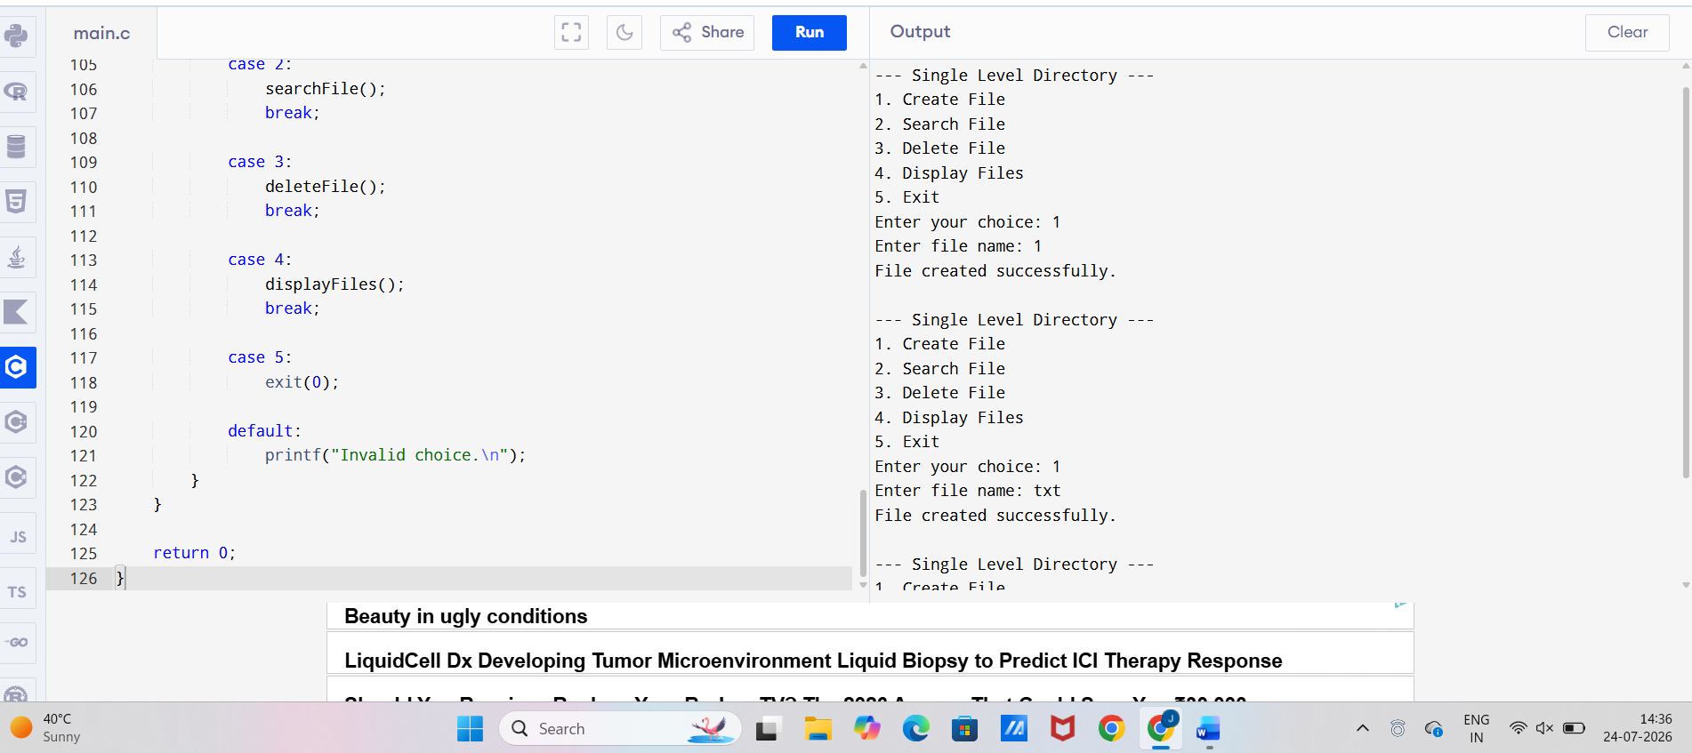

15. Design a C program to organise the file using a two level directory structure.

#include <stdio.h>
#include <stdlib.h>
#include <string.h>

#define MAX_USERS 10
#define MAX_FILES 20

struct user {
char username[20];
char files[MAX_FILES][20];
int fileCount;
};

struct user users[MAX_USERS];
int userCount = 0;

// Create a user
void createUser() {
char uname[20];

printf("Enter username: ");
scanf("%s", uname);

for(int i = 0; i < userCount; i++) {
if(strcmp(users[i].username, uname) == 0) {
printf("User already exists.\n");
return;
}
}

strcpy(users[userCount].username, uname);
users[userCount].fileCount = 0;
userCount++;

printf("User created successfully.\n");
}

// Create a file
void createFile() {
char uname[20], fname[20];
int index = -1;

printf("Enter username: ");
scanf("%s", uname);

for(int i = 0; i < userCount; i++) {
if(strcmp(users[i].username, uname) == 0) {
index = i;
break;
}
}

if(index == -1) {
printf("User not found.\n");
return;
}

printf("Enter file name: ");
scanf("%s", fname);

for(int i = 0; i < users[index].fileCount; i++) {
if(strcmp(users[index].files[i], fname) == 0) {
printf("File already exists.\n");
return;
}
}

strcpy(users[index].files[users[index].fileCount], fname);
users[index].fileCount++;

printf("File created successfully.\n");
}

// Search for a file
void searchFile() {
char uname[20], fname[20];
int index = -1;

printf("Enter username: ");
scanf("%s", uname);

for(int i = 0; i < userCount; i++) {
if(strcmp(users[i].username, uname) == 0) {
index = i;
break;
}
}

if(index == -1) {
printf("User not found.\n");
return;
}

printf("Enter file name to search: ");
scanf("%s", fname);

for(int i = 0; i < users[index].fileCount; i++) {
if(strcmp(users[index].files[i], fname) == 0) {
printf("File found.\n");
return;
}
}

printf("File not found.\n");
}

// Display directory
void display() {
printf("\nTwo Level Directory Structure:\n");

for(int i = 0; i < userCount; i++) {
printf("\nUser: %s\n", users[i].username);

for(int j = 0; j < users[i].fileCount; j++) {
printf(" %s\n", users[i].files[j]);
}

if(users[i].fileCount == 0)
printf(" No files\n");
}
}

int main() {
int choice;

while(1) {
printf("\n--- Two Level Directory ---\n");
printf("1. Create User\n");
printf("2. Create File\n");
printf("3. Search File\n");
printf("4. Display Directory\n");
printf("5. Exit\n");

printf("Enter choice: ");
scanf("%d", &choice);

switch(choice) {
case 1:
createUser();
break;

case 2:
createFile();
break;

case 3:
searchFile();
break;

case 4:
display();
break;

case 5:
exit(0);

default:
printf("Invalid choice.\n");
}
}

return 0;
}

Output:
